Ajinomoto Philippines – Supplier Allocation, Delivery Scheduling & Collaboration Requirements
Workshop, 28 Oct (afternoon) · Oct 28, 2026 · @Srini

1. Workshop context and scope
The afternoon walked through how an approved PR becomes a PO and how delivery dates are agreed with suppliers. The key finding is that PO dates and prices are rarely updated in SAP: real schedules live in the vendor commitment file and in emails, so the system cannot measure supplier delivery or enforce agreed prices.
Item | Detail
Client | Ajinomoto Philippines Corporation (APC), Project Beacon
Session | Agenda Session 3 (afternoon part) – supplier allocation, delivery assignment and commitment, supplier collaboration, 28 Oct 2026
Durvah team | Kishore, Sunit Nighut
Ajinomoto | Chris Ballesteros (Beacon lead), procurement team (Josh and the RM/PM persons in charge), IT
Also covered | Sourcing approach, supplier audit plan, contract repository, system landscape, AI capabilities, user and spend sizing
The morning part (QC receiving, LIMS, rejections and RTV) has its own document. Session 2 covered MRP and the PR–PO flow at a high level; this session adds the detail.

2. Current process (as-is)
Allocation, pricing and delivery scheduling all depend on procurement staff reading several Excel files and re-keying the result into SAP or email.
A. PR to PO
- Planning creates the PR in SAP and the department head approves it, both in SAP and by email. The approved PR is then emailed to procurement as an Excel file.
- The PR lists the material, quantity and three dates per line: ETD from origin, ETA at port and ETA at factory. Dates are back-calculated from the required arrival date using the supplier's lead time. The same SKU often appears on several lines with different dates.
- Planning fills the PR columns. Procurement completes the allocation columns by hand: supplier, allocated quantity and price.
- Allocation rules:
  - Sole-sourced materials go to the one supplier.
  - Multi-sourced materials follow the budget allocation %, adjusted for MOQ and price.
  - Prices are compared in a quarterly price list by supplier and MOQ, with local prices converted to USD for comparison against import suppliers.
  - Final allocation is a buyer decision, not a rule in a system.
- Procurement creates the PO in SAP from the sheet and types in the price.
B. Pricing
- Prices come from the latest supplier quotation, which is often annual but can change mid-year (for example quarterly for some RM).
- Suppliers sometimes announce a price increase only after receiving the PO. APC then negotiates, may shift volume to a cheaper second supplier, and escalates to management.
- There is no formal contract or price agreement with most suppliers, only PO terms and conditions.
- Suppliers quote price breaks by MOQ (for example 100k, 200k, 300k). When a supplier consolidates delivery lines, the PO price is edited by hand to the lower tier.
C. Forecast to suppliers
- Forecasts should go to suppliers monthly but are sent irregularly. Procurement struggles to get updated forecasts from planning, and the Jedox forecast is not updated often enough to rely on.
- PRs sometimes come in well above forecast, and suppliers lack capacity to meet them.
D. Delivery scheduling and commitment
- From the third to the last week of each month, planning updates the vendor commitment (VC) file with the latest required delivery dates from MRP. Planning then emails procurement that the schedule is ready.
- Procurement filters the VC file by plant, open POs and supplier, and emails each supplier the delivery dates and quantities for the month.
- The supplier replies by email whether it can meet the dates. If not, procurement updates planning, the VC file is changed, and the loop repeats.
- PO delivery dates in SAP are normally not amended, especially for PM; only the VC file is updated. SAP therefore shows the original date, and the supplier is legally bound only to the PO.
- Materials are delivered to the plant, where the RM/PM warehouse sits. There are two plants and a new factory is planned.
E. Imports (CIF)
- Import materials are bought CIF. The supplier invoices including freight to the port.
- Customs and broker costs are carried as cost conditions on the SAP PO (a percentage of value). Finance allocates the broker and customs payments.
F. Sourcing
- Full sourcing happens mainly for new materials. RFPs for existing materials are run to find alternatives for sole-sourced items, or when a supplier raises its price.
- Evaluation is sequential: commercial (price within budget) first, then sample, quality and audit. A combined final assessment happens at the four-quadrant QA review, where cost above budget must be explained.
G. Supplier audit
- An annual audit plan covers about 13 suppliers, plus special audits (for example a new warehouse or new material). Suppliers are selected by priority, spend and new-supplier status. A risk database will drive selection in future.
- The audit summary report gives an audit grade with criteria A–H common to all suppliers, signed by the APC auditors, management and the supplier's representative. NCs found in the audit require a supplier CAR.
- The audit score feeds supplier performance (see Session 3).
H. Contracts and landscape
- Signed contracts are kept in hard copy, scanned into a shared contract repository that is also used for sales contracts. The system name needs confirming.
- SAP S/4HANA went live in 2024, replacing QAD (“CC”). WMS dates from 2020. Jedox was in place before 2024.
- SAP's planning modules (MRP, BOM, production) were not studied at implementation, because APC relied on a third-party implementer. Sales orders run in SAP SD. There is no CRM.
- An SAP Ariba sourcing pilot was explored earlier but not continued.

3. As-is process flow
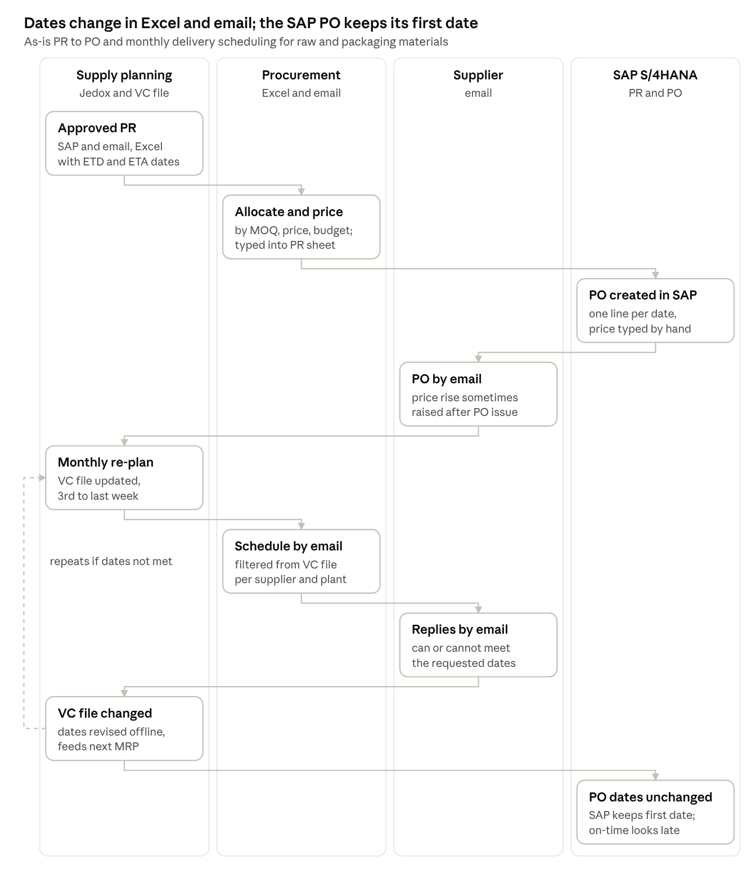
As-is PR to PO and delivery scheduling · 4 lanes, 9 steps
The monthly re-plan loop runs entirely between the VC file and email, so SAP keeps the first PO date even after the supplier agrees a new one.

4. Pain areas
Because revised dates and prices never reach the SAP PO, APC cannot hold suppliers to commitments or measure on-time delivery from the system.
# | Pain area | Impact
P1 | PR approved in SAP and again by email; Excel copy sent to procurement | Double handling; risk of working from an outdated sheet
P2 | Allocation done by hand across the PR sheet, price list, budget and MOQs | Effort; inconsistent decisions; no audit trail
P3 | PO price typed from the latest quotation; no price agreements | Price errors; suppliers raise prices after PO issue
P4 | MOQ price breaks not applied automatically; consolidated lines re-priced by hand | APC may pay a higher tier than it qualifies for
P5 | Same SKU split into many PO lines by date instead of schedule lines | More lines to manage; tier pricing lost
P6 | Forecast not shared with suppliers regularly; Jedox forecast not current | Supplier capacity shortfalls when PRs exceed forecast
P7 | Delivery schedule sent by email from a filtered VC file; acknowledgement by email | Slow, manual monthly cycle per supplier and plant
P8 | SAP PO dates not amended when schedules change | Supplier bound only to the original PO date; on-time delivery shows as late
P9 | Re-planning loops (supplier cannot meet date) handled by email | No history of who changed what and why
P10 | Sequential sourcing (price first, then quality and audit) tracked offline | Long cycle; evaluation not recorded in one place
P11 | Audit plan, checklist and summary in Excel and paper; selection by judgement | No link to risk or performance; signatures on paper
P12 | Contracts kept as scanned hard copies with no expiry alerts | Expired agreements go unnoticed (links to Session 3 CC-01)
P13 | SAP planning functions unused, so MRP, BOM and allocation run outside SAP | Many integrations and Excel links; fragile landscape

5. To-be process
In the target design, POs are priced from agreements and every agreed date change is issued as a PO change order through the supplier portal. The SAP PO, MRP and on-time KPI then always show the date the supplier actually committed to.
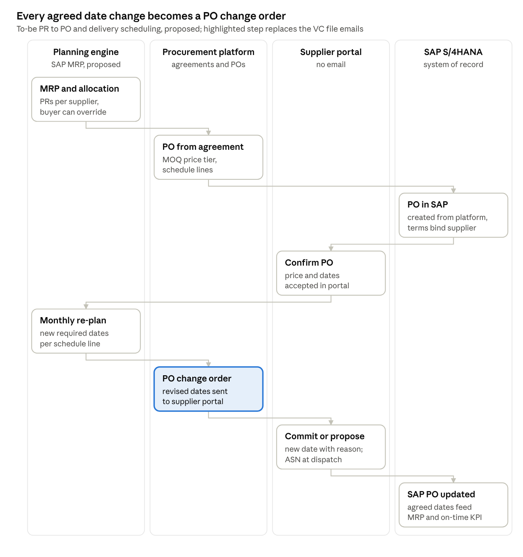
To-be PR to PO and delivery scheduling · 4 lanes, 8 steps
What changes:
- Allocation: allocation % and MOQ rules sit in the planning engine (SAP MRP proposed, to be confirmed on 29 Oct). Buyers review the result instead of building it in Excel.
- Price: comes from a price agreement with MOQ tiers. Suppliers request price changes in the portal, and APC approves them before they apply.
- Schedule lines: one PO line per material carries several delivery dates, which keeps tier pricing and reduces lines.
- Monthly cycle: the re-plan goes to suppliers as a PO change order, not an email from the VC file. Suppliers commit or counter-propose with a reason, and the loop is recorded.
- Forecasts: shared monthly in the portal, so suppliers can confirm capacity ahead of PRs.
- Sourcing and audits: sourcing evaluations, audit plans and audit summaries move into the platform, with digital sign-off by APC and the supplier.

6. Functional requirements
Eighteen requirements came out of this session. Several extend Session 2 (PP-xx) rather than repeat it. Priorities are Durvah's proposal for Ajinomoto to confirm.
ID | Area | Requirement | Priority
SA-01 | PR intake | Receive approved PRs from SAP with ETD, port ETA and factory ETA per line; no email or Excel hand-off | Must
SA-02 | Allocation rules | Allocate by sole-source flag, allocation % from budget, MOQ, price tier and supplier status; buyer reviews and overrides with reason (extends PP-03) | Must
SA-03 | Price agreements | Price per material and supplier held as an agreement with validity and MOQ price tiers; PO price defaults from it | Must
SA-04 | Tier pricing | PO price picks the right MOQ tier automatically, including when delivery lines are consolidated | Should
SA-05 | Price change control | Supplier submits price changes in the portal with effective date; APC negotiates and approves before they apply; POs already accepted keep their price | Must
SA-06 | Schedule lines | One PO line per material with several delivery schedule lines instead of separate lines per date | Should
SA-07 | Forecast sharing | Publish a rolling monthly forecast per supplier and material in the portal, with supplier capacity confirmation | Must
SA-08 | Monthly delivery schedule | Revised required dates from planning published to suppliers per PO schedule line, by plant, replacing the VC file and emails | Must
SA-09 | Supplier commitment | Supplier accepts or proposes a new date and quantity with reason per schedule line (extends PP-06) | Must
SA-10 | PO change order | Agreed date changes update the SAP PO as a formal change order, so the supplier is bound and on-time delivery is measured against the agreed date | Must
SA-11 | Re-plan loop | Planning sees supplier counter-proposals and can re-plan; full change history kept | Must
SA-12 | Import landed cost | Support CIF pricing and Incoterms on PO; customs and broker cost conditions remain in SAP | Should
SA-13 | Sourcing evaluation | RFQ with commercial stage first and technical, quality and audit stages after, plus a combined final score at QA review | Must
SA-14 | Audit planning | Annual audit plan and special audits, selected from risk, spend and performance; checklist with criteria A–H; audit summary signed digitally by APC and the supplier; audit NCs raise CARs | Must
SA-15 | Contract repository | Contracts and price agreements stored with expiry and renewal alerts; integration or migration from the current repository to be decided | Should
SA-16 | Plant and warehouse | Deliveries and schedules by plant, ready for the planned new factory | Must
SA-17 | AI insights | Market and price insights by material and origin, and AI-assisted risk and sustainability input (phase 2) | Could
SA-18 | Data residency | Platform does not store APC data outside agreed regions; AI use controlled by APC | Must

7. Sizing inputs: users and spend
Indicative figures from the discussion, to be confirmed by APC for licence sizing and the business case.
Group | Indicative users | Notes
Procurement (RM and PM) | About 4 | Specialists, one manager, one department head
QA / QC (quality assessment and audit) | About 5 | Three specialists, one manager, one director
R&D | 1 shared, plus approvers | Mainly approvals for new suppliers and items
Planning, finance, management | To be confirmed | Approvers
Suppliers | About 50 RM/PM suppliers | Free supplier access required (Day 1)
Annual spend (FY2025, approximate): about PHP 6 billion in total, of which raw materials are about PHP 5 billion. APC will confirm the figures from total PO value.

8. Open questions
# | Question | For
Q1 | Will APC put price agreements or contracts in place with RM and PM suppliers, so prices cannot change after PO acceptance? | Procurement, management
Q2 | Is APC open to running MRP and allocation in SAP (source list or quota arrangement), with BOMs maintained in SAP? | IT, planning – 29 Oct systems session
Q3 | Should PO delivery dates be formally amended in SAP whenever the monthly schedule changes? | Procurement, planning
Q4 | Can POs use schedule lines instead of one line per date? Does this affect WMS and the ASN design? | IT (SAP and WMS)
Q5 | How often should forecasts go to suppliers, and who owns them: planning or procurement? | Planning, procurement
Q6 | Will the contract repository stay for purchase contracts, or move to the new platform? What is it called? | Legal / admin, IT
Q7 | What are the confirmed user counts by role, and the FY2025 spend by RM and PM? | Procurement, finance
Q8 | Which platforms are on the shortlist beyond the three already named, and is AI in phase 1 or phase 2? | Chris Ballesteros

9. Action items
Nine actions came out of this session. The systems session on 29 Oct (A1) decides where MRP and allocation run, which shapes most of the to-be design. Owners are proposed from the discussion; please confirm.
# | Action | Owner | Due | Status
A1 | Systems and integration session: MRP and BOM in SAP vs Jedox, WMS roadmap, target architecture and timelines | IT, planning (incl. Rachelle), Durvah | 29 Oct | Open
A2 | Share sample PR sheet, quarterly price list (with MOQ tiers) and the allocation sheet | Procurement (Josh) | This week | Open
A3 | Share the VC file extract and supplier delivery schedule email template | Procurement / planning | This week | Open
A4 | Share the audit plan, audit checklist (criteria A–H) and audit summary template | QA / procurement | This week | Open
A5 | Confirm user counts by role and FY2025 spend (total PO value) for licence sizing and the business case | Procurement, finance | Next week | Open
A6 | Confirm the contract repository name and whether purchase contracts move to the new platform | Chris Ballesteros / IT | Next week | Open
A7 | Add sourcing (RFQ and evaluation) to the scope and implementation plan; it was missing from the original module list | Chris Ballesteros, Durvah | With requirements pack | Open
A8 | Propose PO change-order and schedule-line handling between SAP, the platform and WMS | Durvah (Kishore, Sunit) | With requirements pack | Open
A9 | Note AI capabilities (market insights, risk) as a phase 2 option in the evaluation criteria, with data residency terms | Durvah, Chris Ballesteros | Vendor demo prep | Open

